Test Summary
Latchup
 | IF input (GHz, dBm) | LO input (GHz, dBm) | RF Output (GHz, dBm)
Typical Board | 1, -10 | 8, 19 | 7, -19; 9, -20
Transient
 | IF input (GHz, dBm) | LO input (GHz, dBm) | RF Output (GHz, dBm)
Typical Board | 1, -10 | 8, 19 | 7, -19; 9, -20
Brief Test Setup
- Connect all relevant equipment to the chassis (2x rf gen)
- Connect the eval board to the appropriate equipment – see connection diagram (2x rf gens, spectrum analyzer)
- Connect the PXIe4081 to the beam’s TTL Signal
- If latchup, heat die to 150℃. If transient, keep at room temperature
- Use the LabVIEW vi to configure the run information and the rf sources
- Record video of spectrum analyzer
- Irradiate beam
- End beam irradiation
- End LabVIEW power supply reading and the python register read
- Evaluate the data
- Offload data collection folder to separate pc to read

Equipment
- NI PXI 1095 Chassis
  - 8880 controller
  - 4081 dmm
- 2x Signal Generators (Hittite Sig Gens)
- Spectrum Analyzer
- ADMV1530
- >3x rf cables
- >1x 2.4mm to 2.92 FF RF connector
- >2x Right Angle MF RF connector
- >1x HS-USB-GPIB connectors
- 2 – 3 x GPIB connectors
- Camera
- Omega Thermometer
- Thermocouples
Procedure
NOTES
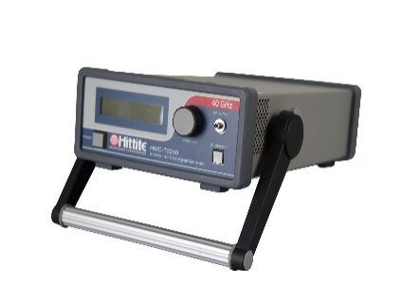
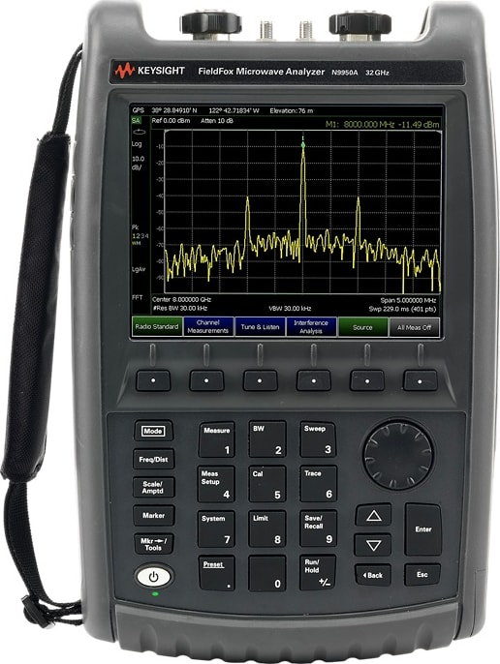
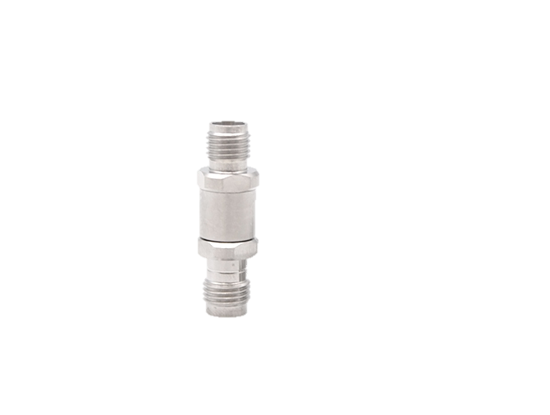
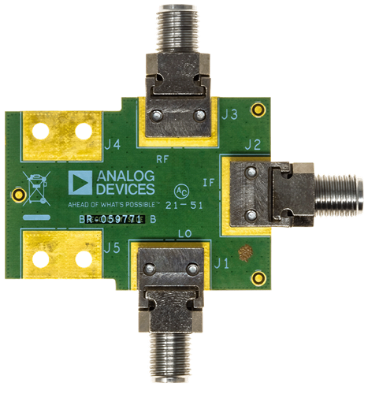

Initial Configuration

- Ensure the device is powered off
- Connect one RF Hittite Signal Generator labelled “GPIB 27” to IF
- Connect a HS-USB-GPIB connector on the between RF Sig Gen “GPIB 27” to the NI Tester
- Connect one RF Hittite Signal Generator labelled “GPIB 12” to LO
- Connect a GPIB to GPIB connect between RF Sig Gen “GPIB 27” and “GPIB 12”
- Connect the PxIe4081 to the beam’s TTL logic via bnc /banana jack adaptor on the patch panel
- If latchup test, put the heat gun on the part and heat to 150 celcius
- Open LabVIEW on NI Tester
- Go to C:\ Git\Rad-Effects-Test-Software\SEE_PXI_TopBench.lvproj
  - If there is a pop up, just press “load with selected”
- If not running, press white arrow
- Configure the “Data Block”
  - Change values in the “Run Data Input” (Green Block)
    - RUN FOLDER
    - DUT
    - ION
    - BOARD NUMBER
    - EFFECTVE LET
    - TEST TYPE (NOTE ONLY DOING LATCHUP THIS CAMPAIGN)
  - Press “Apply Data” in the “Output Echo” Block (right block)
  - Confirm the values are desired
  - Ensure the “Changes Applied?” indicator is bright green
  - Press the Exit button
- Configure the “RF Block”
  - IF = 1Ghz , -10dBm
    - Select the drop down on “VISA resource name”
    - Select GPIB2::27::INSTR
    - Set “frequency” to 1
    - Set “power” to -10
    - Press “Power On”
    - Press Apply Configuration
    - Check the “RF Block Output Echo” for the configuration
  - LO = 1Ghz , -10dBm
    - Select the drop down on “VISA resource name”
    - Select GPIB2::12::INSTR
    - Set “frequency” to 1
    - Set “power” to 19
    - Press “Power On”
    - Press Apply Configuration
    - Check the “RF Block Output Echo” for the configuration
- Configure the Oscilloscope Block
  - Just open and close it. This functionality will be added later
- Begin Data Collection Block
- Confirm that the data is being collected at the levels you are expecting for a unconfigured board
- Confirm that a folder has been created at the run folder specified during STEP 15 A I
- Review the spectrum analyzer output. If there is a tone at 1GHz greater than -7 dBm, you have configured the part properly
- Prepare the beam for irradiation
- On the LabVIEW script, press “record data toggle” when you want to begin
- Record spectrum analyzer via camera
- Once run is complete, press “record data toggle” on the LabVIEW script
- You have completed a run

